Chad Kooienga
Mon 4/15/2019 9:53 AM

https://toolingsystemsgroup.sharepoint.com/TSG/PM20/Customer%20Standards%20Library/Forms/AllItems.aspx?id=%2FTSG%2FPM20%2FCustomer%20Standards%20Library%2FCustomer%20Standards%2FHighlands%20Diversified%2FStandards%2FDie%2FHDS%20Tooling%20guidelines%2Epdf&parent=%2FTSG%2FPM20%2FCustomer%20Standards%20Library%2FCustomer%20Standards%2FHighlands%20Diversified%2FStandards%2FDie

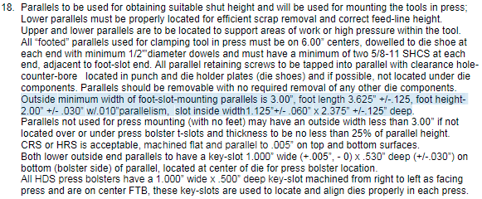

Chad Kooienga
CTS
Designer/Diemaker

ckooienga@toolingsystemsgroup.com
616-264-6952

